**Source:** Here was a file lost off from my records –

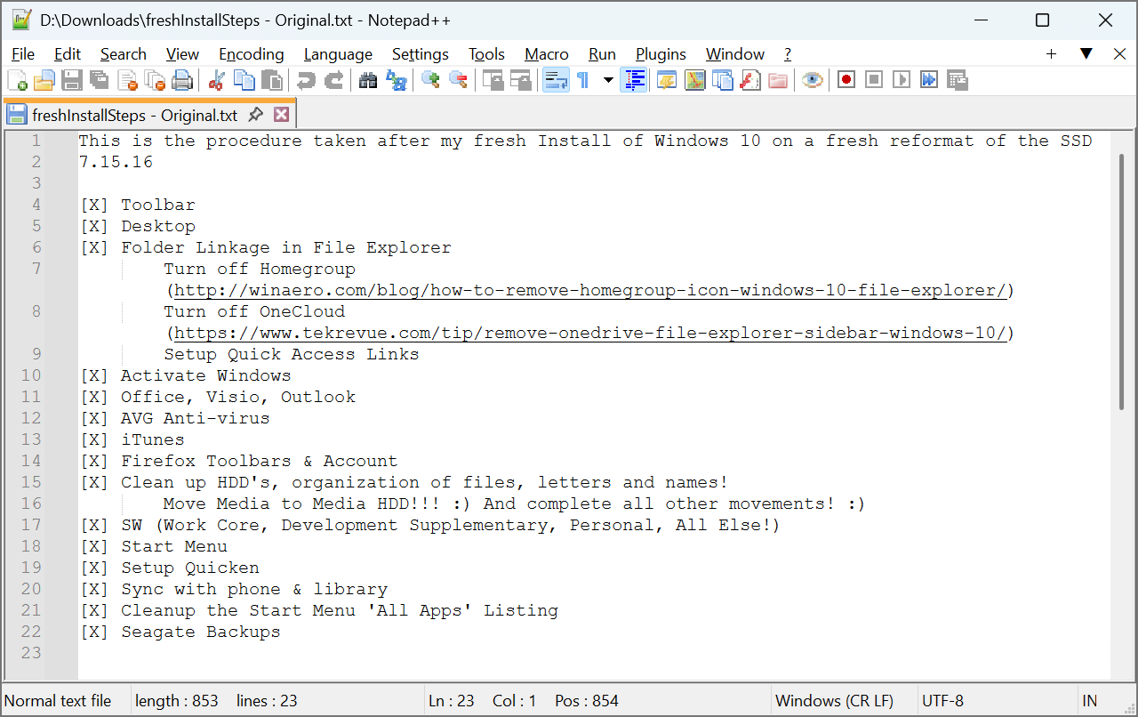

**Figure 1:** Original file, recovered from old how-to installation notes

With sectioned text.txt template applied –

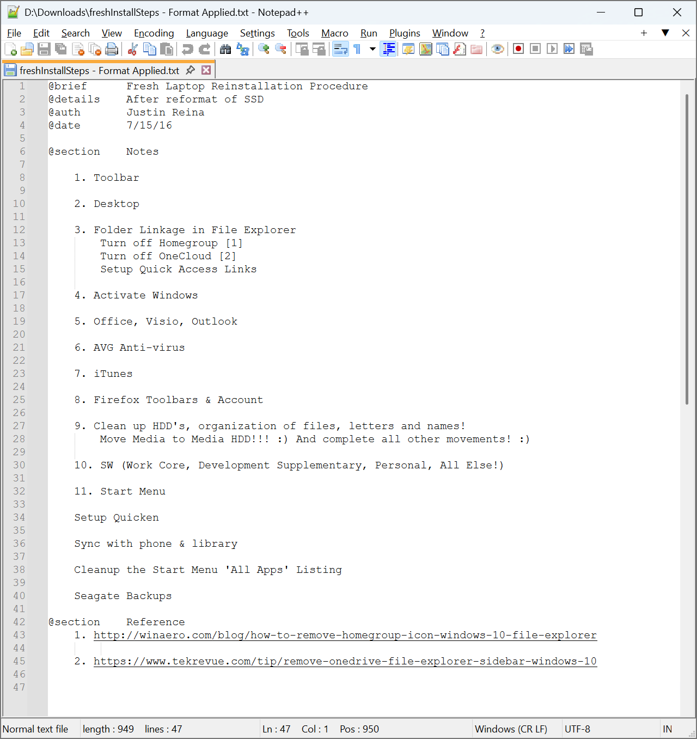

**Figure 2:** Template applied improving readability, portability & support